Two weekend to choose from, but space is filling fast: 1-September 18-19 or 2-September 24-26.
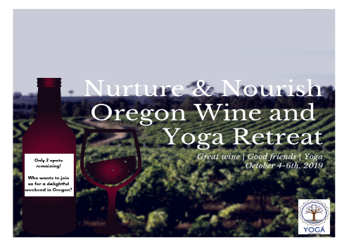
Friday-September 17th, 2021
-all travelers arrive into PDX that are arriving via Air by 11:00 am. Meet in Baggage area.(A small group of us will arrive on Thursday. If you wish to come in early, I can help you make arrangements at the hotel we are staying)
11:30 Lunch at Kennedy School-see menu attached (not included in event fee)
12:45 Chocolate Tasting-Moonstruck Chocolate
2:45 Cheese Tasting

Check in 3:45 La Bastide Bed and Breakfast-
4 pm-Walk to Hyland Estates for our first tasting experience. Enjoy 5 tastings.

5:30 pm-7 pm Appetizers and Wine tasting with our local sponsor-Duck Pond at La Bastide (private event)
8-8:30 pm Close the evening with a Restorative Yoga class

Saturday-September 18
8-9:00 am Partner Yoga Class-with Myo-facial Release. An opportunity to have fun, while enjoying yoga.
9:30-10:30 am- Breakfast
10:50 am leave for Winery Tour: Elk Cove
11:30 am Tasting at Elk Cove
12:30 pm Travel to next Vineyard-Pike Road
1-2:50 Tasting and Lunch on site and tasting. (Lunch from Horse Radish Deli)
2:50 pm Travel to Rex Hill
3:30 pm Rex Hill Experience
6:15 pm leave for dinner
6:30 pm- dinner at Red Hill Market. (Dinner, iced tea and water included)
8:30-9:00 Restorative Yoga to close evening

Sunday-September 19th
8-9:00 Sam Partner Yoga Class-with Myo-facial Release. An opportunity to have fun, while enjoying yoga.
9:30-10:30 Breakfast
10:30-prepare to leave
12 check out and return to Portland Airport
Flights should be booked after 3:30 pm to return home.

(NOTE-agenda and winery's may change slightly)

